Test Case: tc001_SPX_Dev5_Crear_Requisicion_Spot_Tipo_Cobro_CC
Step 1 - Enter username and password and click to button Enter : Credentials Entered
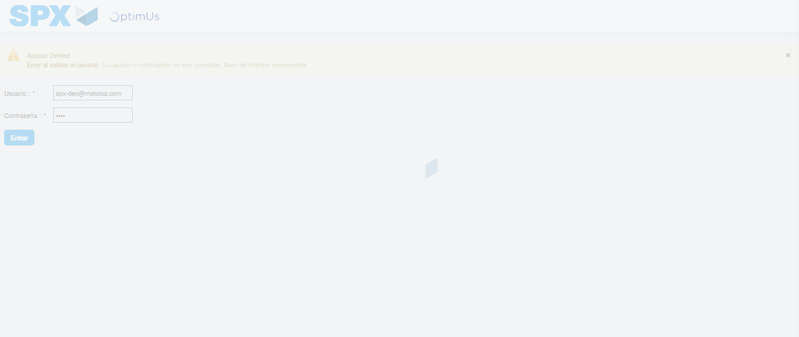Image file-name: QC_Testing-tc001_SPX_Dev5_Crear_Requisicion_Spot_Tipo_Cobro_CC-1788279311323

Step 2 - Select to UEN and Access to Spot Buy Requisitions : UEN Correctly selected and Correct access
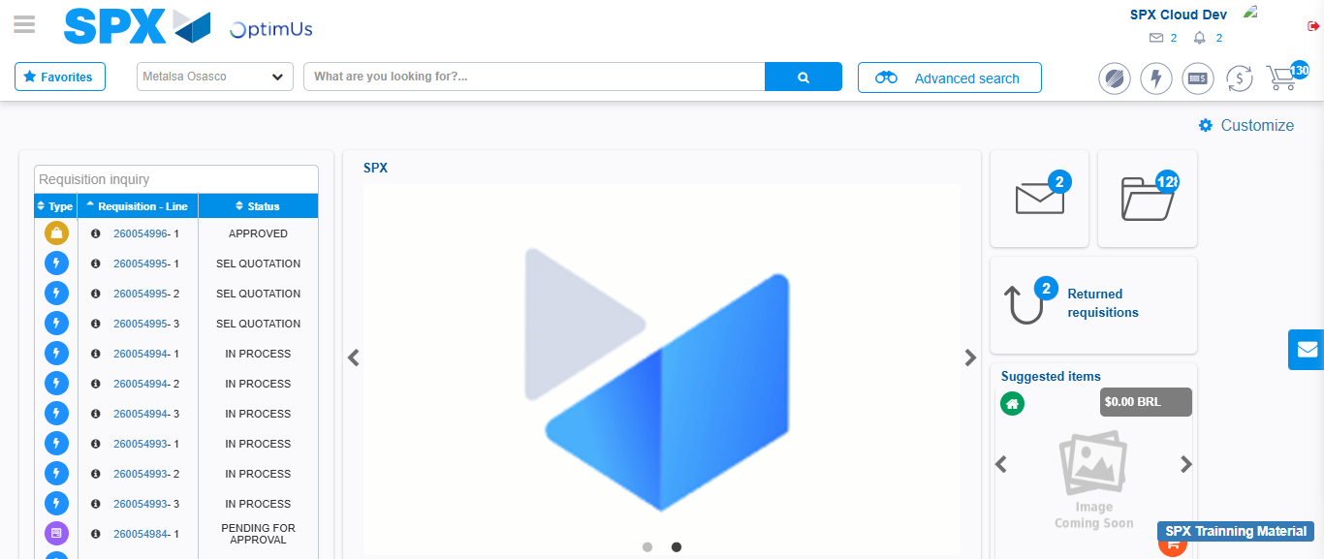Image file-name: QC_Testing-tc001_SPX_Dev5_Crear_Requisicion_Spot_Tipo_Cobro_CC-1788279374705

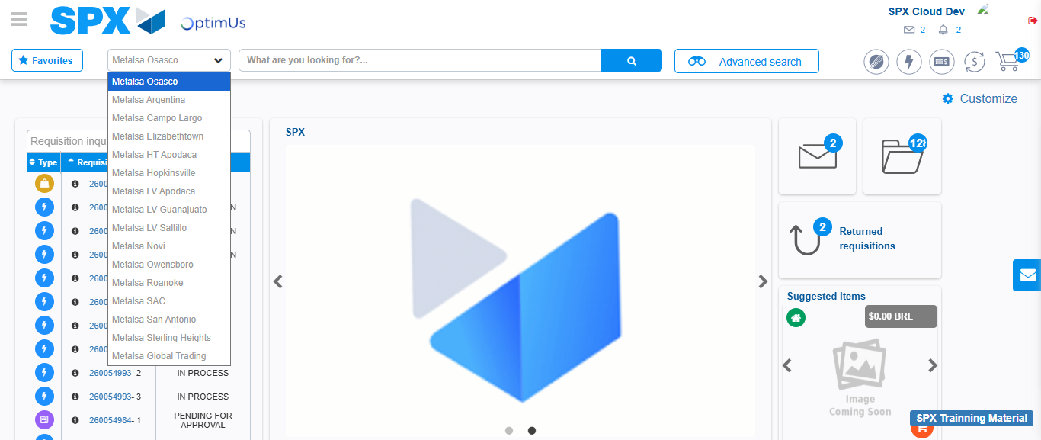Image file-name: QC_Testing-tc001_SPX_Dev5_Crear_Requisicion_Spot_Tipo_Cobro_CC-1788279375444

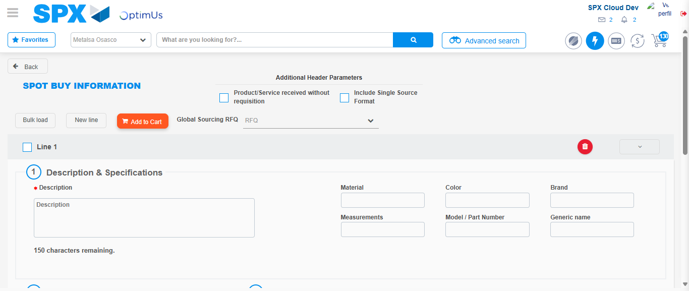Image file-name: QC_Testing-tc001_SPX_Dev5_Crear_Requisicion_Spot_Tipo_Cobro_CC-1788279382527

Step 3 - Data Capture Spot Buy Requisition : Data captured correctly
Image file-name: QC_Testing-tc001_SPX_Dev5_Crear_Requisicion_Spot_Tipo_Cobro_CC-1788279382860

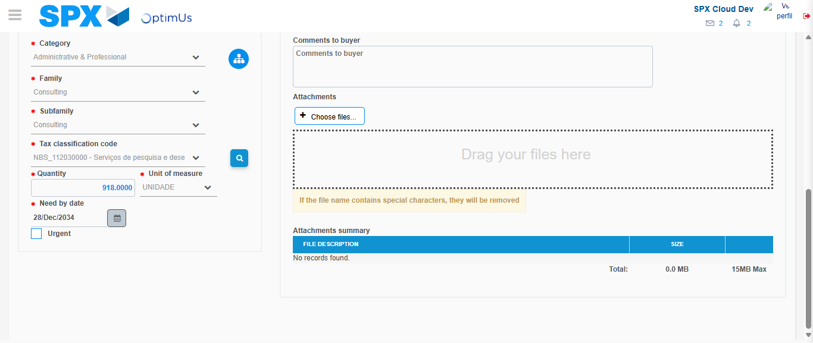Image file-name: QC_Testing-tc001_SPX_Dev5_Crear_Requisicion_Spot_Tipo_Cobro_CC-1788279400300

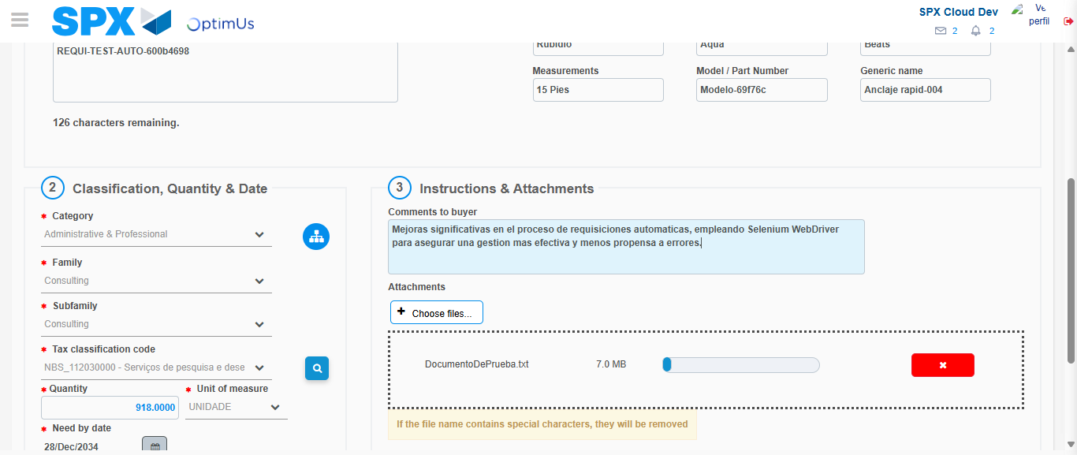Image file-name: QC_Testing-tc001_SPX_Dev5_Crear_Requisicion_Spot_Tipo_Cobro_CC-1788279401133

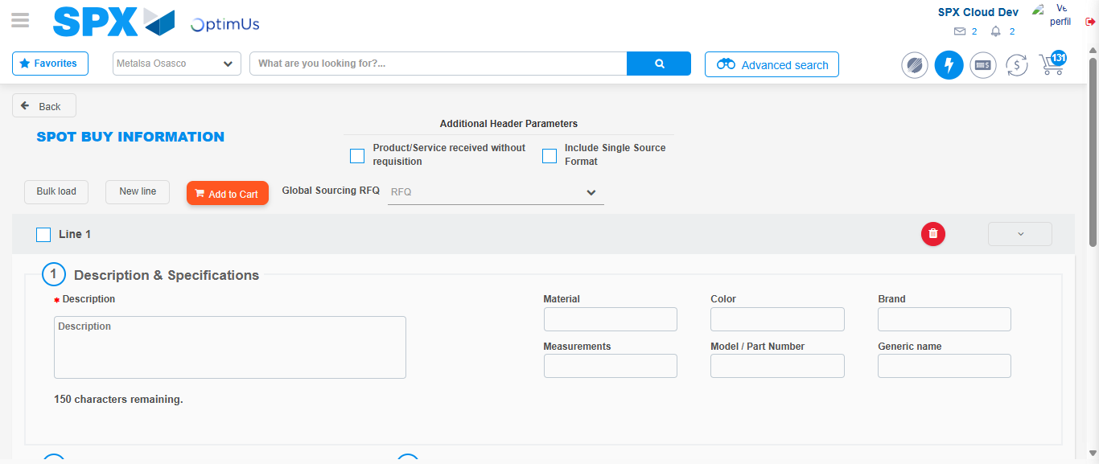Image file-name: QC_Testing-tc001_SPX_Dev5_Crear_Requisicion_Spot_Tipo_Cobro_CC-1788279405318

Step 4 - Select to Requisition : Requisition Correctly selected
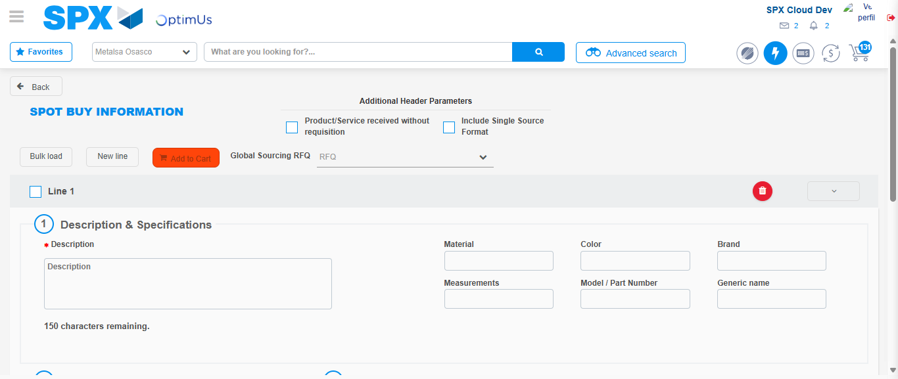Image file-name: QC_Testing-tc001_SPX_Dev5_Crear_Requisicion_Spot_Tipo_Cobro_CC-1788279405584

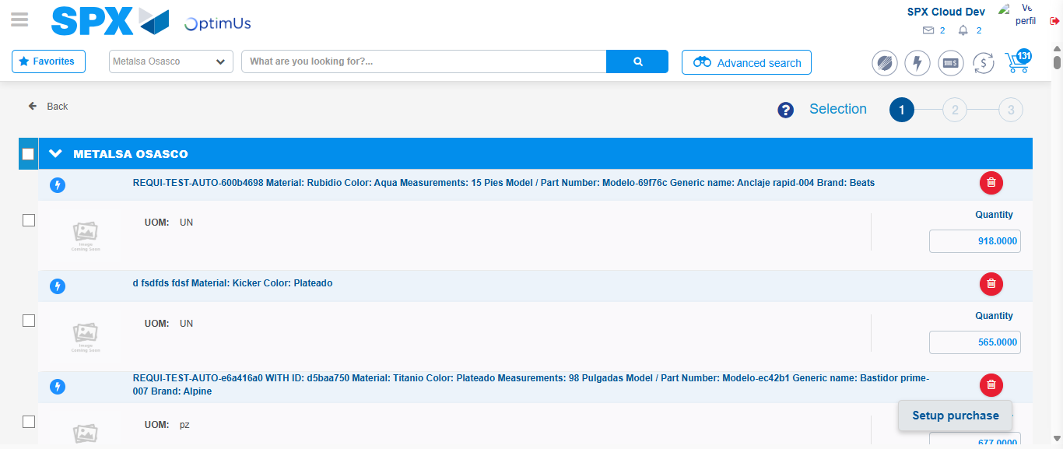Image file-name: QC_Testing-tc001_SPX_Dev5_Crear_Requisicion_Spot_Tipo_Cobro_CC-1788279415721

Image file-name: QC_Testing-tc001_SPX_Dev5_Crear_Requisicion_Spot_Tipo_Cobro_CC-1788279416064

Image file-name: QC_Testing-tc001_SPX_Dev5_Crear_Requisicion_Spot_Tipo_Cobro_CC-1788279416337

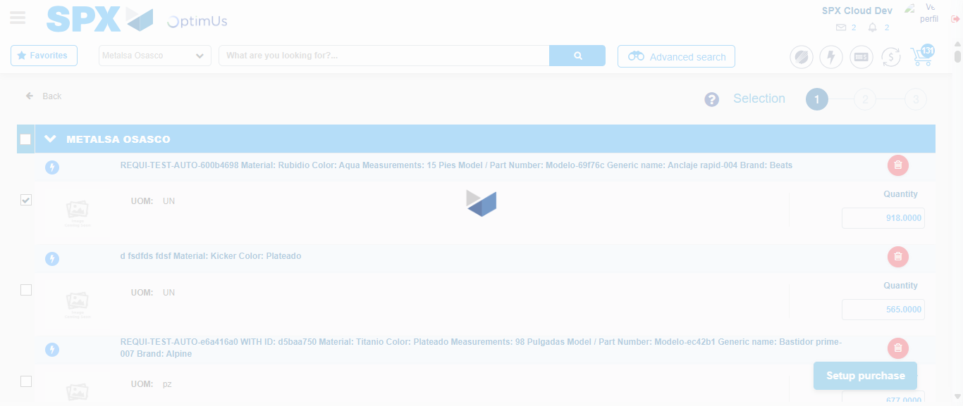Image file-name: QC_Testing-tc001_SPX_Dev5_Crear_Requisicion_Spot_Tipo_Cobro_CC-1788279417879

Step 5 - Select Type Account For Requisition : Type Account Correctly selected
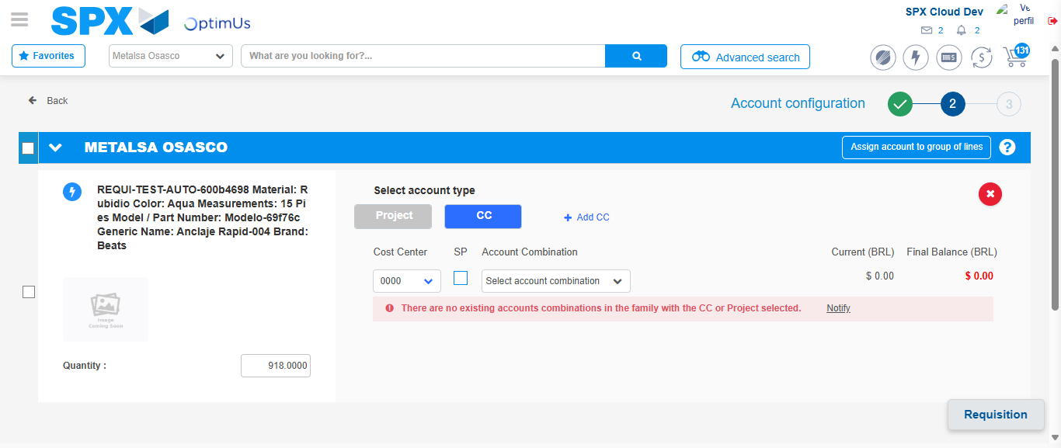Image file-name: QC_Testing-tc001_SPX_Dev5_Crear_Requisicion_Spot_Tipo_Cobro_CC-1788279430133

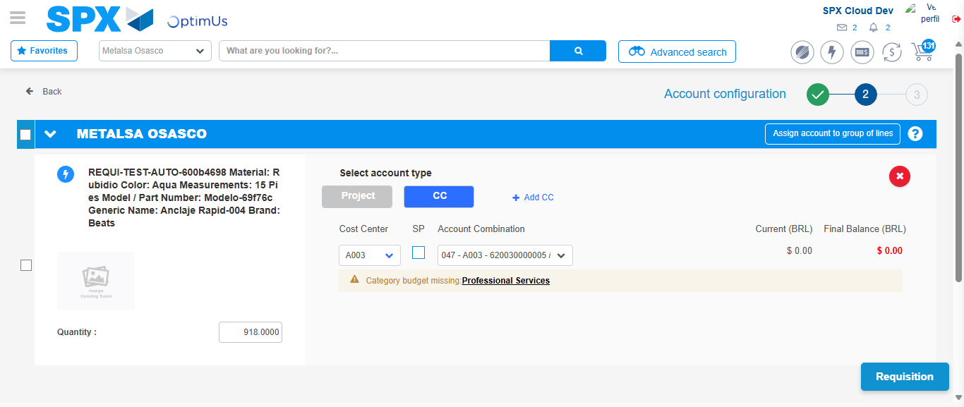Image file-name: QC_Testing-tc001_SPX_Dev5_Crear_Requisicion_Spot_Tipo_Cobro_CC-1788279435648

Image file-name: QC_Testing-tc001_SPX_Dev5_Crear_Requisicion_Spot_Tipo_Cobro_CC-1788279435900

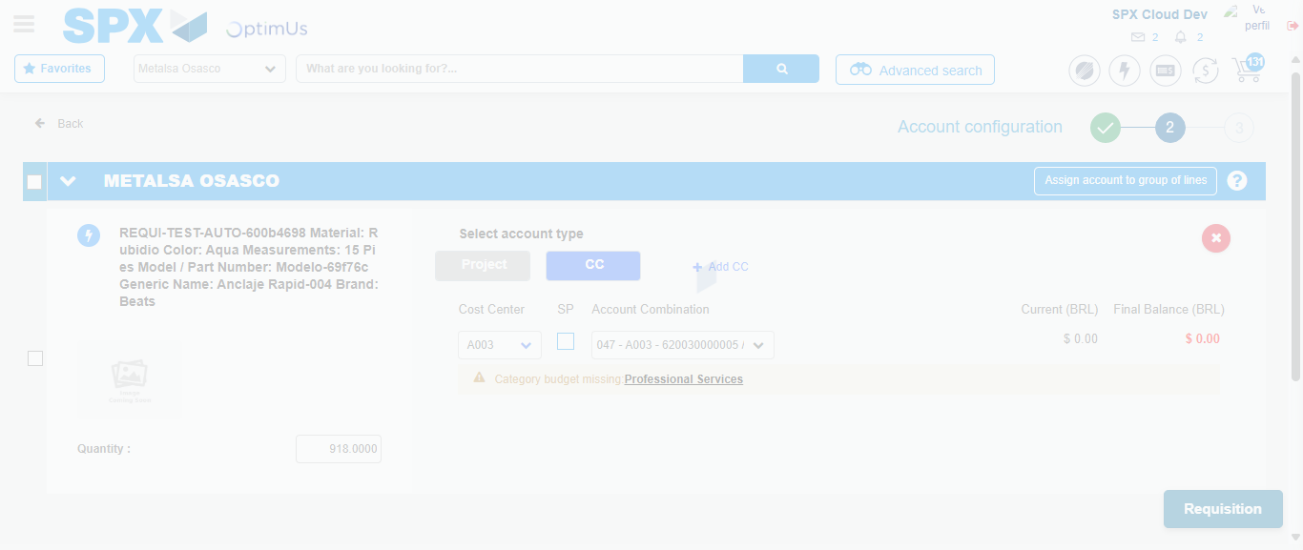Image file-name: QC_Testing-tc001_SPX_Dev5_Crear_Requisicion_Spot_Tipo_Cobro_CC-1788279436391

Step 6 - Accept to Requisition : Requisition Accepted
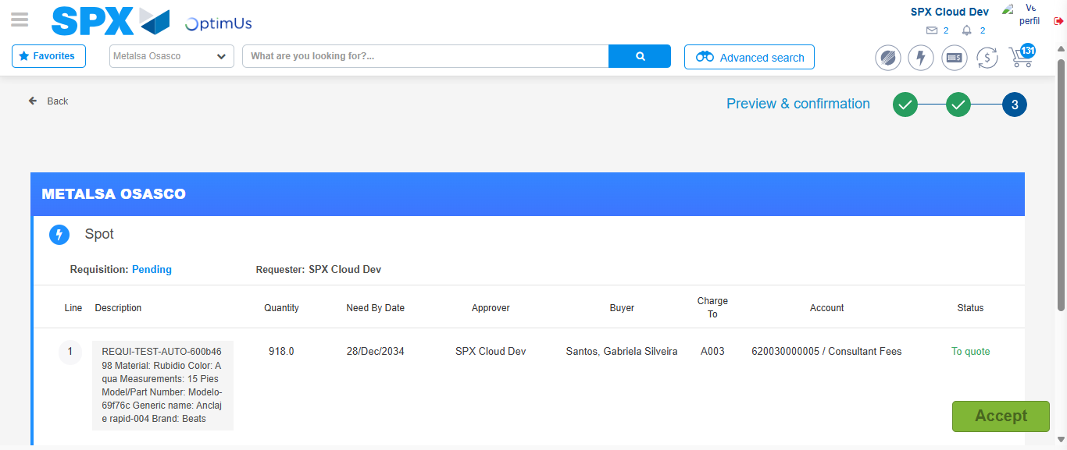Image file-name: QC_Testing-tc001_SPX_Dev5_Crear_Requisicion_Spot_Tipo_Cobro_CC-1788279437783

Image file-name: QC_Testing-tc001_SPX_Dev5_Crear_Requisicion_Spot_Tipo_Cobro_CC-1788279438017

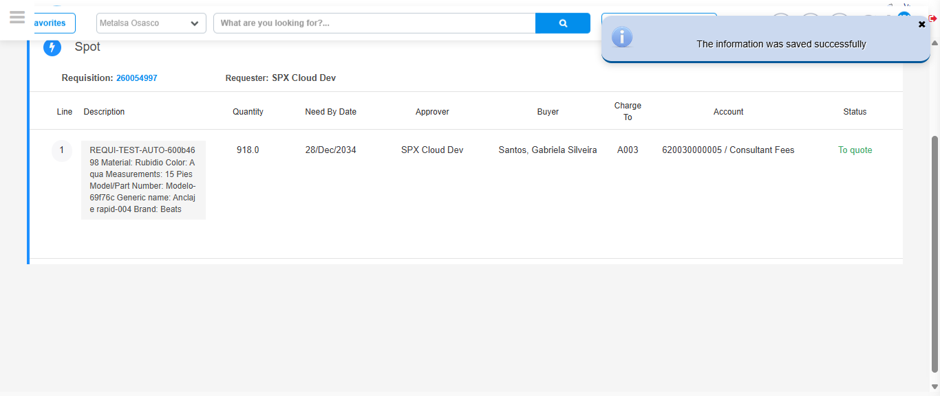Image file-name: QC_Testing-tc001_SPX_Dev5_Crear_Requisicion_Spot_Tipo_Cobro_CC-1788279442694

Step 7 - Return to Main Page SPX : Return to Main Page SPX
Image file-name: QC_Testing-tc001_SPX_Dev5_Crear_Requisicion_Spot_Tipo_Cobro_CC-1788279374705

Image file-name: QC_Testing-tc001_SPX_Dev5_Crear_Requisicion_Spot_Tipo_Cobro_CC-1788279375444

Image file-name: QC_Testing-tc001_SPX_Dev5_Crear_Requisicion_Spot_Tipo_Cobro_CC-1788279382527

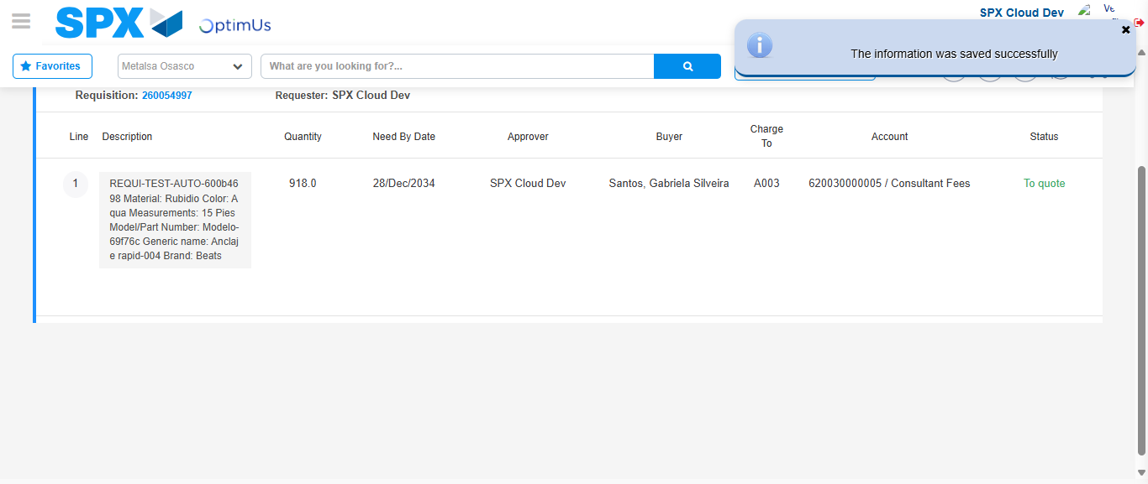Image file-name: QC_Testing-tc001_SPX_Dev5_Crear_Requisicion_Spot_Tipo_Cobro_CC-1788279445025

Image file-name: QC_Testing-tc001_SPX_Dev5_Crear_Requisicion_Spot_Tipo_Cobro_CC-1788279445268

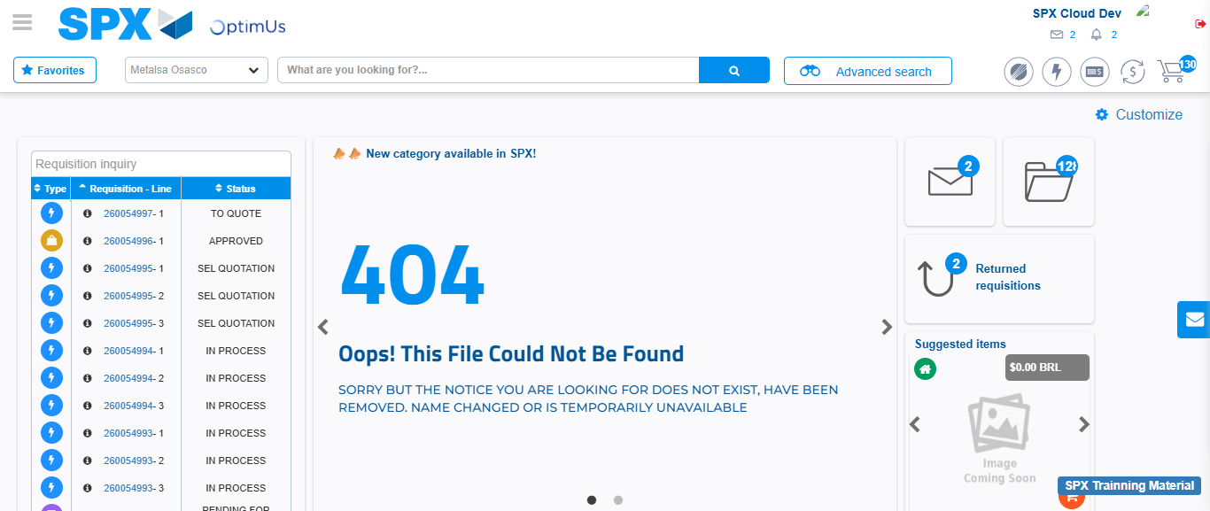Image file-name: QC_Testing-tc001_SPX_Dev5_Crear_Requisicion_Spot_Tipo_Cobro_CC-1788279466777

Step 8 - Log Out : Log Out SPX
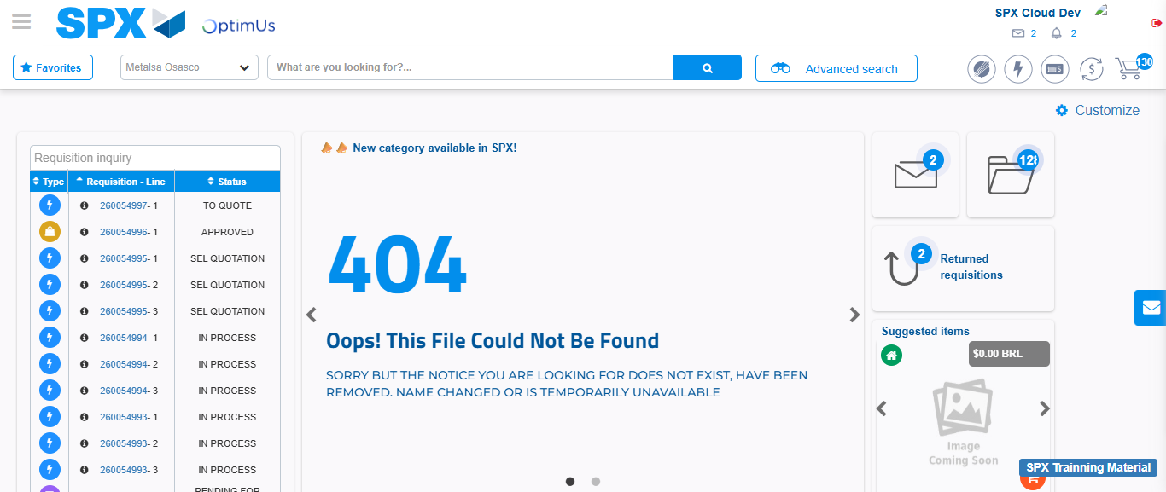Image file-name: QC_Testing-tc001_SPX_Dev5_Crear_Requisicion_Spot_Tipo_Cobro_CC-1788279467196

